Efficient production at any batch size
B&R at the SPS IPC Drives
B&R will be presenting the SuperTrak industrial transport system at the SPS IPC Drives trade fair. Dependable, precise and remarkably low maintenance – it enables agile, efficient production at any batch size. Other highlights on display at the B&R booth (Hall 7 / Booth 206) include a multitude of new mapp components and connected manufacturing solutions based on OPC UA communication.
Two years ago, B&R radically simplified the development of machine software with the introduction of mapp Technology. These precoded and thoroughly tested software components have since been making life easier for OEMs by taking low-level programming tasks for basic functions off their hands. Encouraged by outstanding market acceptance in this short time, B&R has continued to expand its software framework – offering even greater savings to customers developing applications in the areas of CNC, robotics, complex closed-loop control and HMI.
Solutions for connected manufacturing
B&R will also be taking the opportunity to present numerous communication solutions for the connected factory envisaged by Industry 4.0. By combining OPC UA and openSAFETY to create Safe Line Automation, B&R offers seamless and scalable safety throughout integrated production lines. B&R will also be presenting a cloud solution for its APROL process control system.
Advanced system architecture for commercial vehicles
With B&R's X90 system, manufacturers of construction, agricultural and municipal vehicles can now benefit from B&R's 35 years of automation experience. In addition to the new control and I/O system, these applications can profit from B&R's Automation Studio development environment, mapp software framework and global support network.

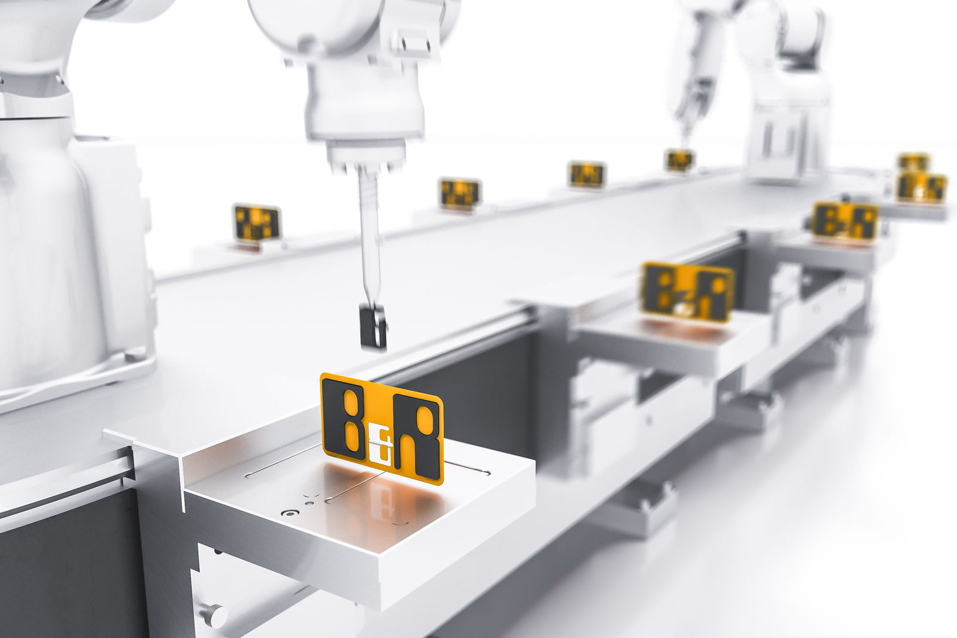
At the SPS IPC Drives trade fair, B&R will be presenting the SuperTrak industrial transport system and numerous solutions for connected manufacturing.

B&R Hakkında
B&R, Avusturya'da genel merkezi ve tüm dünyada ofisleri bulunan yenilikçi bir otomasyon şirketidir. 6 Temmuz 2017 tarihinden bu yana B&R, ABB Group bünyesinde bir iş birimi olarak faaliyet sürdürmektedir. Endüstriyel otomasyonda bir dünya lideri olan B&R, gelişmiş mühendislik bilgisini modern teknoloji ile harmanlıyor. B&R, makine ve fabrika otomasyonu, tahrik ve kontrol teknolojisi, görselleştirme ve entegre emniyet teknolojisinde çeşitli sektörlerden müşterilerine bütünsel çözümler sunmaktadır. Endüstriyel loT ile OPC UA, POWERLINK ve openSAFETY gibi iletişim standartlarının yanı sıra Automation Studio yazılım geliştirme ortamının da sayesinde B&R geleceğin otomasyon mühendisliğini yeniden tanımlıyor. B&R, yenilikçi çözümleri ile otomasyon dünyasında yeni standartlar belirledi, süreçleri basite indirgemeye ve müşterilerin beklentilerinin ötesine geçmeye yardımcı oldu.
Daha fazla bilgi için www.br-automation.com.tr adresini ziyaret edebilirsiniz.

