Humans and robots, hand in hand
B&R presents new solutions at Anuga FoodTec
New solutions for cooperation between humans and robots in the food and beverage industry will be the focal point of B&R's exhibit in Hall 7 / Booth 39 at the Anuga FoodTec trade fair being held March 24-27 in Cologne, Germany.
"Our SafeROBOTICS functions eliminate the need for a safety cage and allow robots and human operators to work hand in hand," explains Enrico Paolucci, B&R's global account manager for the food and beverage industry. In addition to the already well-established functions for monitoring the speed of a robot's joints and tool center point (TCP), B&R's range of SafeROBOTICS functions has been expanded to include monitoring of workspace boundaries and the orientation of the tool mounting flange. "This makes it even easier to achieve the higher levels of flexibility and tighter integration of robotics and automation demanded by Industry 4.0."
"With the fourth industrial revolution, the complexity of production processes is growing rapidly," says Paolucci. In an effort to adapt to these new challenges, food and beverage companies are increasingly turning to automation technology. "That's why we're making our first appearance at Anuga FoodTec this year." B&R offers food and beverage producers integrated automation solutions that can increase their competitive edge as they transition to Industry 4.0.

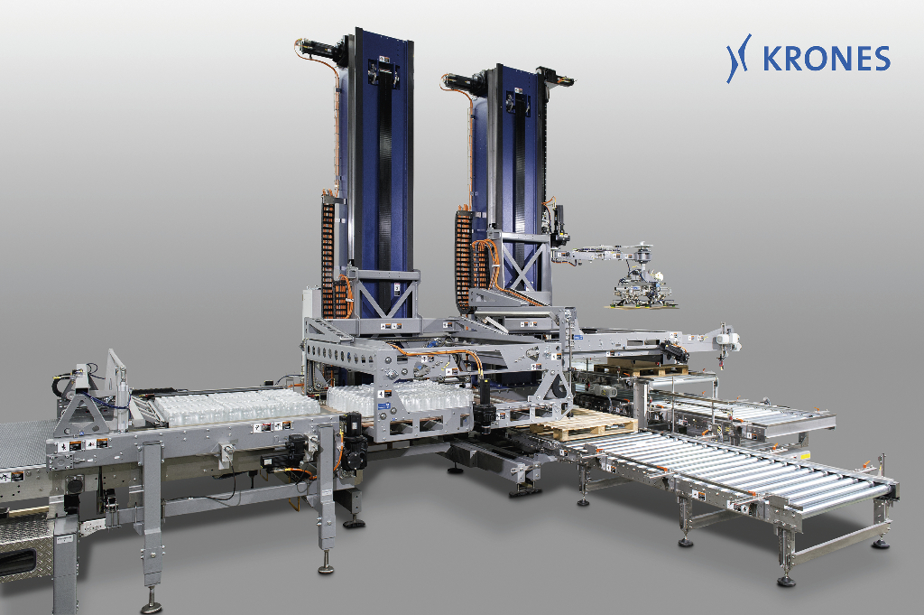
B&R technology provides the high degree of production flexibility essential for companies in the food and beverage industry to meet the challenges of the future. A control and drive system from B&R allows this palletizer to react to changes in the production process – flexibly and fully automatically. Photo: KRONES AG

A proposito di B&R
Giunta ai suoi primi trent’anni di presenza in Italia, B&R è un'innovativa società di automazione con sede in Austria e uffici in tutto il mondo. B&R è la business unit per la Machine and Factory automation del gruppo ABB. Come leader mondiale nell'automazione industriale, B&R combina tecnologia all'avanguardia e ingegneria avanzata per for-nire ai clienti in ogni settore industriale soluzioni complete per l'automazione di macchina e di fabbrica, per il controllo di movimento, per l'interfaccia uomo macchina e le tecnologie di sicurezza integrate. Sfruttando gli standard di comunicazione per l’IIoT come OPC UA, TSN, POWERLINK e openSAFETY, insieme al potente ambiente di sviluppo software Automation Studio, B&R sta costantemente ridefinendo il futuro dell'ingegneria di automazione. Lo spirito innovativo che mantiene B&R all'avanguardia nell'automazione industriale è guidato dall’impegno nel semplificare i processi e superare le aspettative dei clienti.
Per ulteriori informazioni, visitare https://www.br-automation.com.

