B&R en la Feria Drinktec 2013 de Múnich
Modular automation system for the construction machinery industry
At bauma 2013 from April 15-21, B&R will be presenting its full range of mobile automation solutions in Hall D / Booth D1.216. The highlight of B&R's bauma appearance will be two of the technology leader's latest developments.
With its new MA170 control and I/O systems, B&R is mixing things up in the field of construction machinery automation. What's so revolutionary about these systems is their modular design, an approach B&R has perfected in the area of industrial automation and is now bringing to the world of mobile machinery. The mobile automation product range is rounded off by an automation panel, which serves as a central element to provide integrated control, operation and visualization of vehicles and mobile equipment.
The B&R Automation Studio engineering environment streamlines development of complete solutions that are efficiently scalable and easy to maintain. This fully-integrated, high-performance tool helps engineers master every aspect of an automation project, with loads of convenient features such as an extensive collection of preprogrammed software libraries.
Una nueva dimensión en la comunicación de datos
B&R's mobile devices are equipped with CAN bus, as is obligatory for vehicles, as well as the option of using POWERLINK, the open and fast real-time standard. As an Ethernet-based protocol, POWERLINK is built for high bandwidth communication, with plenty of capacity to handle demanding applications involving sensors and image processing without requiring any auxiliary hardware or software.

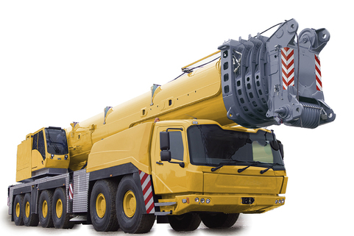
At bauma 2013, B&R will be presenting its full range of mobile automation solutions in Hall D / Booth D1.216, featuring groundbreaking innovations in modular automation for construction machinery.

Acerca de B&R
B&R es una innovadora empresa de automatización con sede en Austria y oficinas en todo el mundo. Como líder mundial en automatización industrial, B&R combina tecnología punta con ingeniería avanzada para ofrecer a los clientes, en prácticamente todas las industrias, soluciones completas para automatización de máquinas y fábricas, control de movimiento, HMI y tecnología de seguridad integrada. Con estándares industriales de comunicación de bus de campo como POWERLINK y openSAFETY, además del potente entorno de desarrollo de software Automation Studio, B&R está constantemente redefiniendo el futuro de la automatización. El espíritu innovador que mantiene a B&R al frente de la automatización industrial está impulsado por el compromiso de simplificar los procesos y superar las expectativas del cliente.
Para más información, visite www.br-automation.com.
Si publica esta nota de prensa, por favor envíe una copia a:
Bernecker & Rainer Automatización industrial S.L.U.
Vallsolana Garden Business Park
Camí de Can Camps, 17-19
08174 Sant Cugat del Vallés
Barcelona
o al e-mail: office.es@br-automation.com

