B&R sponsord practical instruction
Active learning is extremely important at the elementary school in Eggelsberg.For this reason, we wanted to do our part by making a donation in cooperation with the "education highway" initiative sponsored by Upper Austria.Our donation made it possible to provide the school with a "Technikbox", a collection of hundreds of chemistry and physical science experiments that presented new classroom learning opportunities for the children – something that makes principal Annemarie Stegbuchner very happy.With the "Technikbox", students can develop and carry out their own experiments while collecting valuable technical experience along the way."Kids at this age in particular are extremely hungry for new knowledge and are very open to new ideas," said Stegbuchner. "The experiments included in the 'Technikbox' provide us with another avenue for underpinning learning by demonstrating the practicality of the acquired knowledge."
It's not just the teachers who benefit from the extra support in the classroom; the experiments themselves are fun, which adds to the students' enjoyment. "It is very important to arouse the child's interest in things like natural science and chemistry at an early age," said Franz Enhuber, director of the B&R Automation Academy. "We made this donation because we want to help children discover their own talents for understanding technical interrelationships."

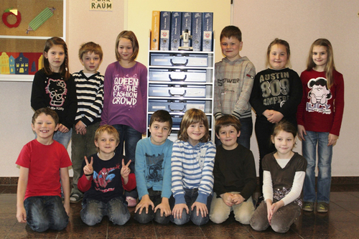
The students at Eggelsberg's elementary school are pleased with the new "Technikbox". It allows them to learn about science independently by conducting experiments in the fields of physics and chemistry.

Acerca de B&R
B&R es una innovadora empresa de automatización con sede en Austria y oficinas en todo el mundo. Como líder mundial en automatización industrial, B&R combina tecnología punta con ingeniería avanzada para ofrecer a los clientes, en prácticamente todas las industrias, soluciones completas para automatización de máquinas y fábricas, control de movimiento, HMI y tecnología de seguridad integrada. Con estándares industriales de comunicación de bus de campo como POWERLINK y openSAFETY, además del potente entorno de desarrollo de software Automation Studio, B&R está constantemente redefiniendo el futuro de la automatización. El espíritu innovador que mantiene a B&R al frente de la automatización industrial está impulsado por el compromiso de simplificar los procesos y superar las expectativas del cliente.
Para más información, visite www.br-automation.com.
Si publica esta nota de prensa, por favor envíe una copia a:
Bernecker & Rainer Automatización industrial S.L.U.
Vallsolana Garden Business Park
Camí de Can Camps, 17-19
08174 Sant Cugat del Vallés
Barcelona
o al e-mail: office.es@br-automation.com

