500,000th POWERLINK system installed
At this year's Hanover Trade Fair, B&R and the EPSG officially handed over the 500,000th POWERLINK system to the international packaging machine manufacturer MediSeal, a member of the KÖRBER MEDIPAK Group. With their main focus on the pharmaceuticals and cosmetics industries, the long-term B&R customer's machine solutions require maximum safety, performance and flexibility.
The high-performance fieldbus will be used for motion control. "POWERLINK ensures optimum drive synchronization - a decisive advantage for complex motion tasks like the ones required for our highly dynamic packaging lines," states Winfried Holtey, R&D specialist for electrical engineering at MediSeal.
POWERLINK, which was introduced in 2001, is currently implemented by more than 2,500 machine manufacturers worldwide and, through the use of open source technology, is the only completely open and license-free system available on the market.
"Other industrial Ethernet network systems either provide synchronization ranging from mediocre to good, or they are specialized in cross-communication," explains Frank Winter, General Manager of B&R Germany. POWERLINK guarantees real-time data exchange between bus stations with the highest level of synchronization. And this is true regardless of the topology used. The performance of POWERLINK can't be beat, especially when synchronizing large numbers of servo axes and I/O channels.

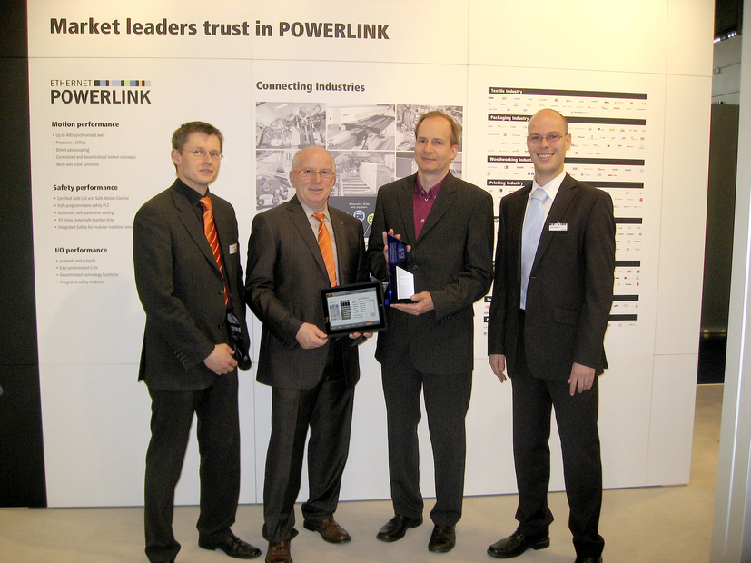
Holger Rudolf, B&R (left), Frank Winter, General Manager of B&R Germany (middle left) and EPSG Manager Stefan Schönegger (right), officially handing over the 500,000th POWERLINK system to Winfried Holtey, MediSeal.

Acerca de B&R
B&R es una innovadora empresa de automatización con sede en Austria y oficinas en todo el mundo. Como líder mundial en automatización industrial, B&R combina tecnología punta con ingeniería avanzada para ofrecer a los clientes, en prácticamente todas las industrias, soluciones completas para automatización de máquinas y fábricas, control de movimiento, HMI y tecnología de seguridad integrada. Con estándares industriales de comunicación de bus de campo como POWERLINK y openSAFETY, además del potente entorno de desarrollo de software Automation Studio, B&R está constantemente redefiniendo el futuro de la automatización. El espíritu innovador que mantiene a B&R al frente de la automatización industrial está impulsado por el compromiso de simplificar los procesos y superar las expectativas del cliente.
Para más información, visite www.br-automation.com.
Si publica esta nota de prensa, por favor envíe una copia a:
Bernecker & Rainer Automatización industrial S.L.U.
Vallsolana Garden Business Park
Camí de Can Camps, 17-19
08174 Sant Cugat del Vallés
Barcelona
o al e-mail: office.es@br-automation.com

