Open Automation Conferences 2011 in India: Cost optimization with POWERLINK and openSAFETY
The central themes of the Open Automation Technology Conferences 2011 were how companies can not only reduce costs, but simultaneously increase productivity through the use of open technologies and standards such as POWERLINK and openSAFETY for automation in the manufacturing sector. The conferences took place on 21 and 22 July in Coimbatore and Chennai in India. More than 200 visitors were invited by the Confederation of Indian Industry and the PSG College of Technology Coimbatore as well as the PSG Science and Technology Entrepreneurial Park, who organized the conference. The event was supported by the Ethernet POWERLINK Standardization Group (EPSG), B&R, and Kalycito.
Stefan Schönegger, Open Automation Business Unit Manager at B&R and General Manager of the EPSG, opened the event with an introduction to open automation, focusing on the pivotal role of automation protocols and networks. Schönegger demonstrated the particular cost advantages that POWERLINK and openSAFETY offer through their flexibility and scalability as opposed to patented systems. Bhagath Singh Karunakaran, the Managing Director of Kalycito India, explained how simply these protocols can be implemented and which components are necessary to do so. Representatives from Hyundai Motor Company and SEW were amongst those giving presentations at the conference in Chennai. Stefan Schönegger said, “The Open Automation Conferences in India were a great success. The high number of participants showed us the importance that open, patent-free technologies have in the emerging industrial nations.”

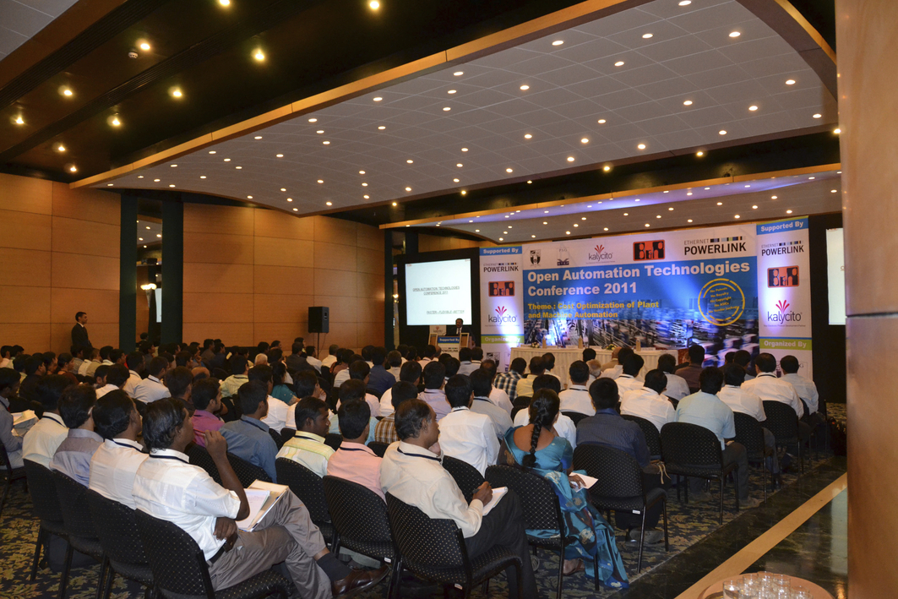
Open Automation Technology Conference in Coimbatore
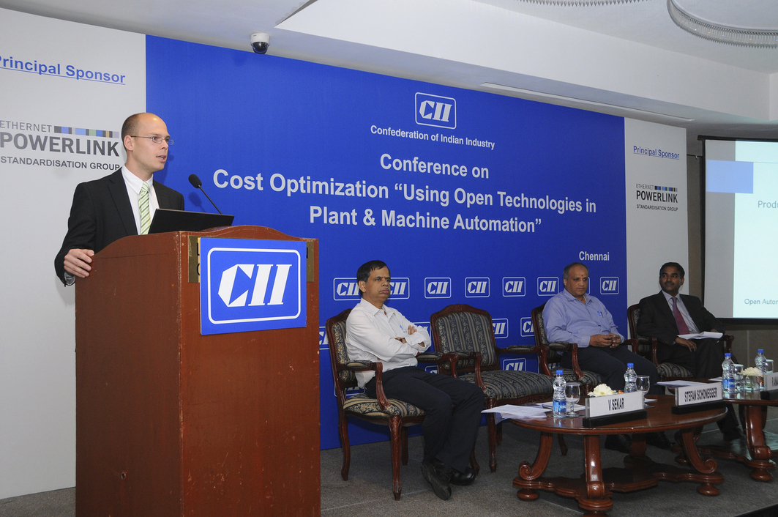
Stefan Schönegger, Open Automation Business Unit Manager at B&R, and General Manager of the EPSG, greets the participants in the Chennai conference

Acerca de B&R
B&R es una innovadora empresa de automatización con sede en Austria y oficinas en todo el mundo. Como líder mundial en automatización industrial, B&R combina tecnología punta con ingeniería avanzada para ofrecer a los clientes, en prácticamente todas las industrias, soluciones completas para automatización de máquinas y fábricas, control de movimiento, HMI y tecnología de seguridad integrada. Con estándares industriales de comunicación de bus de campo como POWERLINK y openSAFETY, además del potente entorno de desarrollo de software Automation Studio, B&R está constantemente redefiniendo el futuro de la automatización. El espíritu innovador que mantiene a B&R al frente de la automatización industrial está impulsado por el compromiso de simplificar los procesos y superar las expectativas del cliente.
Para más información, visite www.br-automation.com.
Si publica esta nota de prensa, por favor envíe una copia a:
Bernecker & Rainer Automatización industrial S.L.U.
Vallsolana Garden Business Park
Camí de Can Camps, 17-19
08174 Sant Cugat del Vallés
Barcelona
o al e-mail: office.es@br-automation.com

