Consortium including Airbus and the French National Railway Corporation define openSAFETY as standard
openSAFETY, the first completely open safety-oriented data transfer protocol for use in all areas of automation, has been declared an official communication standard by the DDASCA Consortium (Dependable Distributed Architecture for Safety Critical Applications). This consortium - formed in Paris in March 2011 on the initiative of Arion Entreprise, EADS, HPC Project, ENSTA, Alstom Power, EDF R&D, SNCF, Windriver, B&R, and others - handles the standardization, definition and implementation of open solutions for safety-critical applications up to SIL4. These solutions are then applied in a wide range of areas, from factory automation and energy management to the railway, automotive, medical and defense industries.
The DDASCA Consortium brings together suppliers, manufacturers, integrators, users and academics who are involved in applications that demand high levels of dependability. By selecting innovative safety technologies such as openSAFETY, the consortium continues to promote modular approaches based on scalable solutions that use open, standardized components.
openSAFETY on all bus systems
With openSAFETY, the EPSG offers the first 100% open safety protocol in the world. Its openness isn't restricted to just the legal definition, either; the word "open" applies in a technical sense as well. Thanks to the total independence of openSAFETY, users can use this technology for all fieldbus systems, industrial Ethernet applications or industry-specific communication solutions.

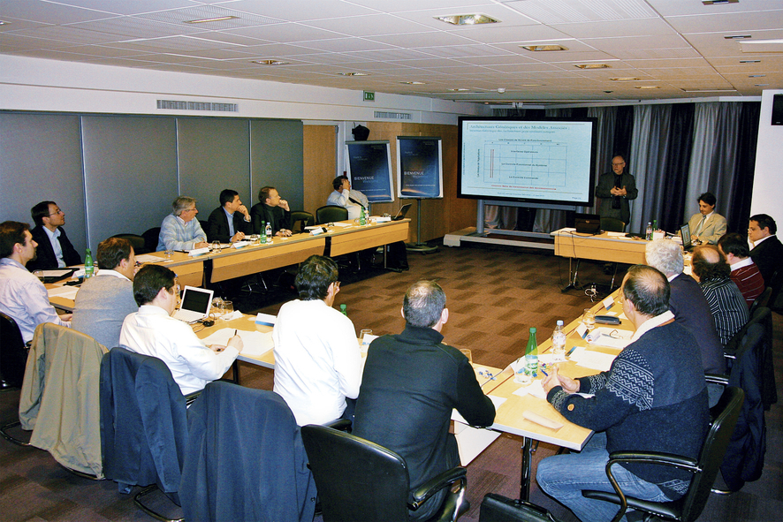
The founding meeting of the DDASCA Consortium in Paris brought together representatives from the aviation, aerospace, medical, and railway industries as well as the energy sector and leading research institutions.

Acerca de B&R
B&R es una innovadora empresa de automatización con sede en Austria y oficinas en todo el mundo. Como líder mundial en automatización industrial, B&R combina tecnología punta con ingeniería avanzada para ofrecer a los clientes, en prácticamente todas las industrias, soluciones completas para automatización de máquinas y fábricas, control de movimiento, HMI y tecnología de seguridad integrada. Con estándares industriales de comunicación de bus de campo como POWERLINK y openSAFETY, además del potente entorno de desarrollo de software Automation Studio, B&R está constantemente redefiniendo el futuro de la automatización. El espíritu innovador que mantiene a B&R al frente de la automatización industrial está impulsado por el compromiso de simplificar los procesos y superar las expectativas del cliente.
Para más información, visite www.br-automation.com.
Si publica esta nota de prensa, por favor envíe una copia a:
Bernecker & Rainer Automatización industrial S.L.U.
Vallsolana Garden Business Park
Camí de Can Camps, 17-19
08174 Sant Cugat del Vallés
Barcelona
o al e-mail: office.es@br-automation.com

